**IBM-EPBL/IBM-Project-20074-1659711991**

Natural Disasters Intensity Analysis and Classification using Artificial Intelligence

**TEAM MEMBERS:**

**412419104051-KAVANA RAO Y**

**412419104012-ARCHANA K**

**412419104128-SUDHARSHINY T A**

**412419104045-JOE MARIAM.J**

**412419104107-SAUJANYA K**

**PRIOR KNOWLEDGE**

SUPERVISED AND UNSUPERVISED LEARNING

**SUPERVISED LEARNING**

In Supervised learning,the machine learns under supervision.It contains a model that is able to predict with the help of a labeled dataset.A labeled dataset is one where you already know the target answer.

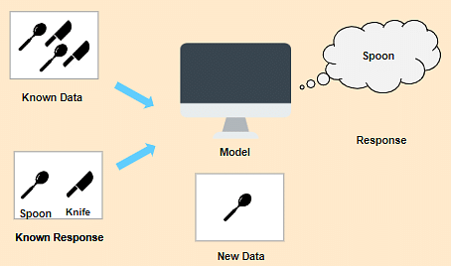

Supervised learning is classified into two categories of algorithms:

1. **Classification :** A classification problem is when the output variable is a category, such as “Red” or “Blue”, “disease”or “no disease”.
2. **Regression:** A regression problem is when the output variable is a real value, such as “dollars” or “weight”.

**UNSUPERVISED LEARNING**

In Unsupervised Learning, the machine uses unlabeled data and learns on its own without any supervision.The machine tries to find a pattern in the unlabeled data and gives a response.

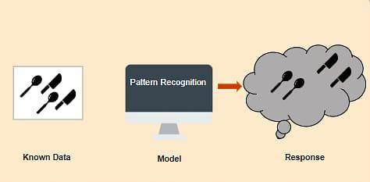

Unsupervised learning can be further grouped into types:

**1.Clustering:**

Clustering is the task of dividing the population or data points into a number of groups such that data points in the same groups are more similar to other data points in the same group and dissimilar to the data points in the other groups.

**2.Association:**

Association is a rule-based machine learning to discover the probability of the co-occurence of items in a collection.For example, finding out which products were purchased together.

**REAL-LIFE OF APPLICATIONS**

Real-Life of Applications of Unsupervised Learning algorithms is:

* **Market Basket Analysis:**It is a machine learning model based on the algorithm that if you buy a certain group of items, you are less or more likely to buy another group of items.
* **Semantic Clustering:** Semantically similar words share a similar context.People post their queries on websites in their own ways.Semantic clustering groups all these responses with the same meaning in a cluster to ensure that the customer finds the information they want quickly and easily.
* **K-means algorithm:**K-means Clustering algorithm is in which the unlabeled dataset is divided into different clusters.Here K defines the number of predefined clusters that need to be created in the process.

**ARTIFICIAL NEURAL NETWORKS IN DEEP LEARNING**

An Artificial neural network is usually a computational network based on biological neural networks that construct the structure of the human brain. Similar to how a human brain has neurons interconnected to each other, artificial neural networks also have neurons that are linked to each other in various layers of the networks. These neurons are known as nodes.Artificial neural network tutorial covers all the aspects related to the artificial neural network.

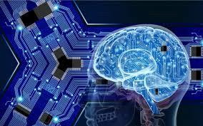

**Convolutional Neural Network**

(CNN) are one of the most popular models used today. This neural network computational model uses a variation of multilayer perceptrons and contains one or more convolutional layers that can be either entirely connected or pooled. These convolutional layers create feature maps that record a region of image which is ultimately broken into rectangles and sent out for nonlinear processing.

**Recurrent Neural Network**

(RNN) are more complex. They save the output of processing nodes and feed the result back into the model (they did not pass the information in one direction only). This is how the model is said to learn to predict the outcome of a layer. Each node in the RNN model acts as a memory cell, continuing the computation and implementation of operations. If the network’s prediction is incorrect, then the system self-learns and continues working towards the correct prediction during backpropagation.